# Gold Trend Insights system

### **Problem Statement**

In today’s financial world, where uncertainty and volatility are common, gold has become a reliable investment choice. Unlike stocks, which can change rapidly and unpredictably, gold has a history of stability and holds intrinsic value. This makes it appealing for investors who want to protect their wealth.

However, the gold market is influenced by many factors, including:

* **Economic indicators** (like interest rates)
* **Geopolitical events** (such as conflicts or trade agreements)
* **Currency fluctuations** (changes in currency values)
* **Supply and demand** (how much gold is available versus how much people want to buy)

These factors can cause short-term price changes, making it harder for investors to decide when to buy or sell.

While there are many models for predicting stock prices, gold trading requires a different approach. Current models often don’t capture the unique aspects of gold pricing.

Investors need a specialized application that uses historical data and analyzes the various factors affecting gold prices. This app would help users make informed decisions by providing accurate predictions and insights specifically designed for the gold market.

### **Key Objectives:**

1. **Understand the Unique Factors:** Identify and analyze the specific factors influencing gold prices, distinct from those affecting stocks.
2. **Develop Predictive Models:** Create robust predictive models that utilize historical data and real-time market information to forecast gold price movements.
3. **User-Friendly Interface:** Design an intuitive application that presents predictions and insights in an easily digestible format, enabling investors to make timely decisions.

By addressing these objectives, the proposed application aims to bridge the gap in the current investment landscape, offering gold investors a powerful tool to navigate the complexities of the gold market effectively.

### **Solution Proposal: Gold Trend Insights**

### We propose the development of a Gold Trend Insights program designed to provide users with daily and hourly gold price predictions over specified time frames. This system aims to empower investors by delivering timely, data-driven insights that enhance decision-making and maximize investment potential in the gold market.

## **Key Features:**

### **1. Predictive Analytics Engine**

* **Data points Identification:**
  + We have pinpointed key data points that are crucial for accurate gold price predictions.
  + **Model** Utilizes past three months of data, with specific focus on one month and one day’s predictions for high/low and open/close prices, also with weighted average.

### **Delta Points Analysis:**

* + Incorporates delta points for:
    - USA time
    - Asian time
    - Actual day delta
    - Previous day delta
  + Analyzes average volume over the last hour and daily average delta to enhance prediction accuracy.

### **2. Model Accuracy and Confidence**

### **Historical Data Utilization:**

* + The model's accuracy will be assessed using extensive historical data.

### **Confidence Intervals:**

* + Display confidence intervals alongside predictions to inform investors of potential variability and risk.

### **3. Sentiment Analysis**

### **Comprehensive Market Insights:**

* + Conduct sentiment analysis on:
    - Economic indicators
    - Geopolitical events
    - Overall market sentiment
  + This feature aims to provide users with context that may influence gold price movements, enabling more informed trading decisions.

#### **Architecture:**

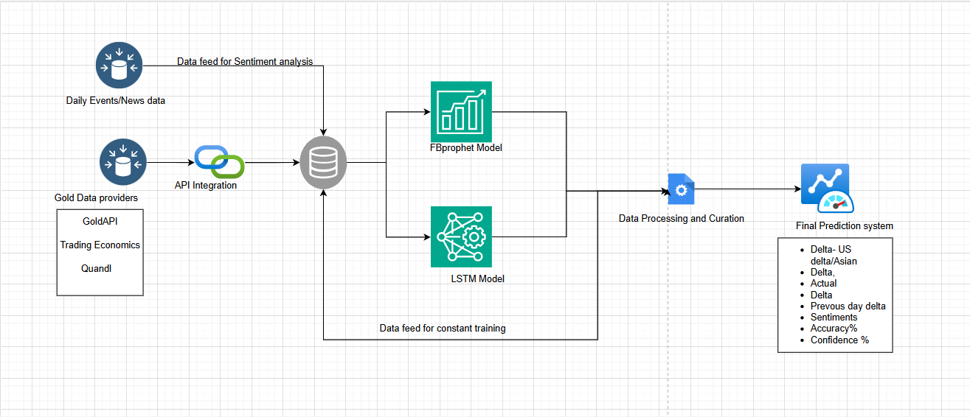

### **Data Collection**: The system will pull data from various gold data sources using API and bring it into data store for model inputs.

### **AI/ML Algorithms**:

We are leveraging FBProphet and LSTM (Long Short-Term Memory) models for gold price prediction, combining the strengths of both approaches to enhance forecasting accuracy. FBProphet is particularly effective for capturing seasonal patterns and trends in time series data, making it ideal for modeling gold price fluctuations influenced by various temporal factors. Meanwhile, the LSTM model excels at learning complex temporal dependencies, allowing it to effectively analyze historical price data and recognize intricate patterns over longer periods. By integrating these two methodologies, we can create a robust predictive framework that not only identifies trends but also adapts to the inherent volatility of the gold market, ultimately providing more reliable and actionable insights for investors.

**Deep Learning Models**: **(RNNs):** Long Short-Term Memory (LSTM) networks and BERT are used for sentiment analysis as they can capture long-range dependencies in text.

### **User Interface**: A user-friendly interface will provide investors with easy access to performance metrics, alerts, and the ability to customize trading strategies.

#### **Expected Outcomes:**

* **Informed Decision-Making:** Users will gain access to actionable insights, enabling them to make informed trading decisions based on predictive data.
* **Increased Investment Confidence:** By utilizing a sophisticated system tailored to the unique characteristics of the gold market, investors will feel more confident in their trading strategies.

### **Enhanced Profitability:** With timely predictions and analysis, users can better capitalize on market movements, potentially increasing their returns on investment.

## **Conclusion**

The Automated Gold Trading System (AGTS) is designed to be a robust tool for investors in the gold market. By integrating advanced predictive analytics, real-time data analysis, and comprehensive sentiment evaluation, the AGTS will empower users to navigate the complexities of gold trading effectively. We believe this system will significantly enhance users’ ability to make informed investment decisions, ultimately maximizing their potential returns in a volatile market.